💜 BTS – Complete Discography
1. Korean Albums
Year | Album Name
2013 | 2 COOL 4 SKOOL
2013 | O!RUL8,2?
2014 | Skool Luv Affair
2014 | Dark & Wild
2015 | The Most Beautiful Moment in Life, Pt.1
2015 | The Most Beautiful Moment in Life, Pt.2
2016 | The Most Beautiful Moment in Life: Young Forever
2016 | Wings
2017 | You Never Walk Alone
2017 | Love Yourself: Her
2018 | Love Yourself: Tear
2018 | Love Yourself: Answer
2019 | Map of the Soul: Persona
2020 | Map of the Soul: 7
2020 | BE
2022 | Proof
2026 | ARIRANG
2. Japanese Albums
Year | Album Name
2014 | Wake Up
2016 | Youth
2018 | Face Yourself
2020 | Map of the Soul: 7 – The Journey
3. Popular BTS Songs
2013–2015
- No More Dream
- We Are Bulletproof Pt.2
- N.O
- Boy In Luv
- Just One Day
- Danger
- War of Hormone
- I NEED U
- DOPE
- RUN
2016–2017
- Fire
- Save ME
- Blood Sweat & Tears
- Spring Day
- Not Today
- DNA
- Best Of Me
- MIC Drop
- Go Go
- Pied Piper
2018–2019
- FAKE LOVE
- IDOL
- Anpanman
- Euphoria
- Singularity
- Epiphany
- Serendipity
- Boy With Luv
- HOME
- Dionysus
2020–2022
- Black Swan
- ON
- Filter
- My Time
- Louder Than Bombs
- Dynamite
- Life Goes On
- Blue & Grey
- Telepathy
- Dis-ease
- Butter
- Permission to Dance
- Yet To Come
- Run BTS
- For Youth
2026 – ARIRANG
- Body to Body
- Hooligan
- Aliens
- FYA
- 2.0
- No. 29
- SWIM
- Merry Go Round
- NORMAL
- Like Animals
- They Don't Know 'Bout Us
- One More Night
- Please
- Into the Sun
4. BTS Website-এর জন্য আরও কিছু Section
তোমার website-এ এই navigation menu রাখতে পারো:
- HOME – BTS-এর introduction এবং banner।
- ABOUT US – BTS-এর history এবং journey।
- MEMBERS – RM, Jin, SUGA, j-hope, Jimin, V, Jung Kook।
- DISCOGRAPHY – Albums এবং songs।
- MUSIC VIDEOS – Official music videos।
- GALLERY – BTS photos।
- ACHIEVEMENTS – Awards এবং records।
- ARMY – BTS fandom সম্পর্কে
Official Discography: BIGHIT MUSIC – BTS Discography 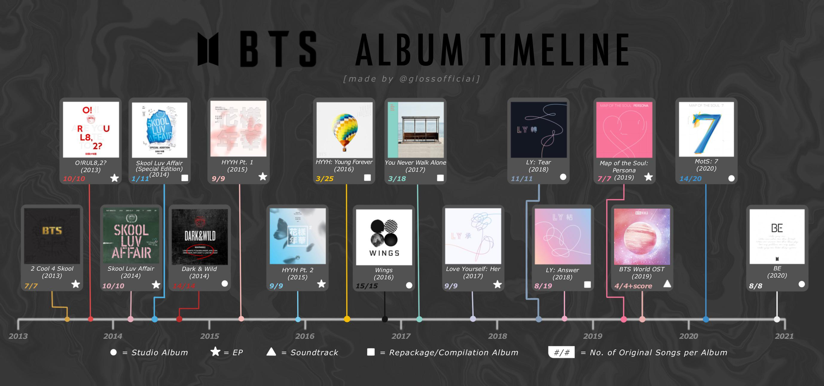
DEBUET

